AI LAB ASSIGNMENT-8.1
NAME:P.BHARGAVI
BATCH:44
2303A52391
Task Description #1 (Password Strength Validator – Apply AI inSecurity Context)

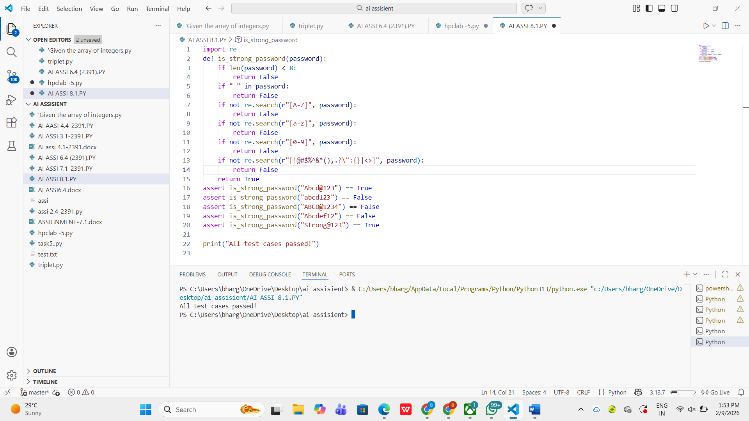

Task Description #2 (Number Classification with Loops – ApplyAI for Edge Case Handling)

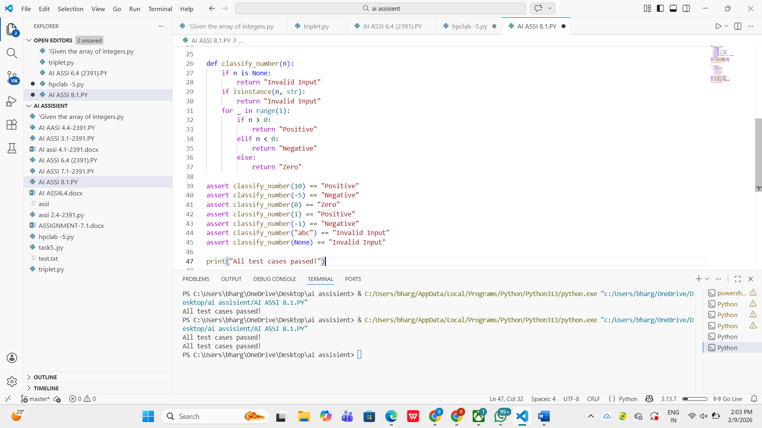

Task Description #3 (Anagram Checker – Apply AI for StringAnalysis)

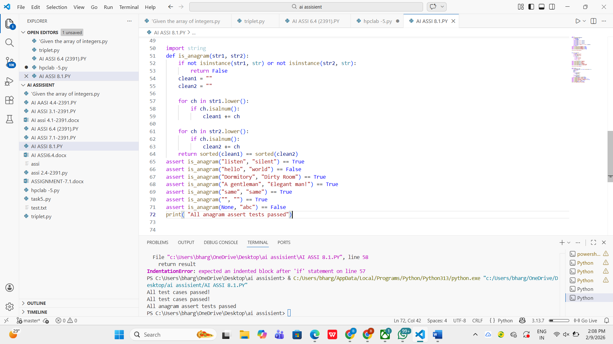

Task Description #4 (Inventory Class – Apply AI to Simulate Real-World Inventory System)

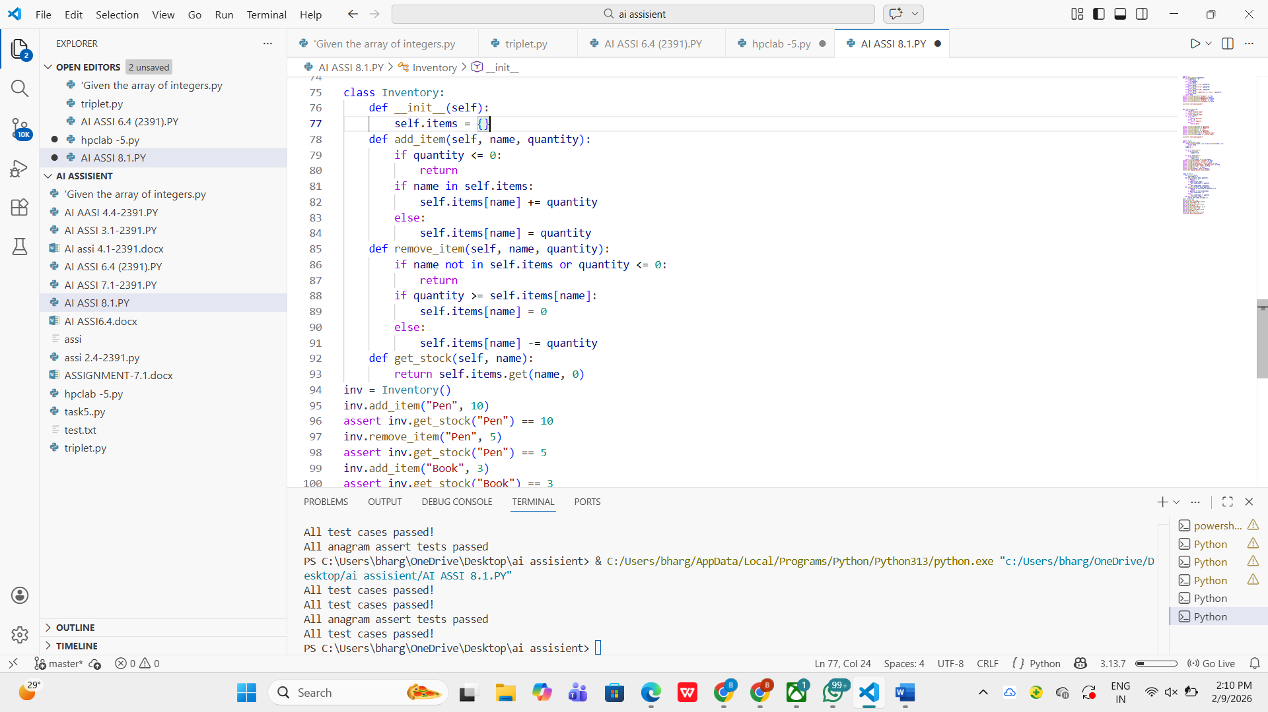

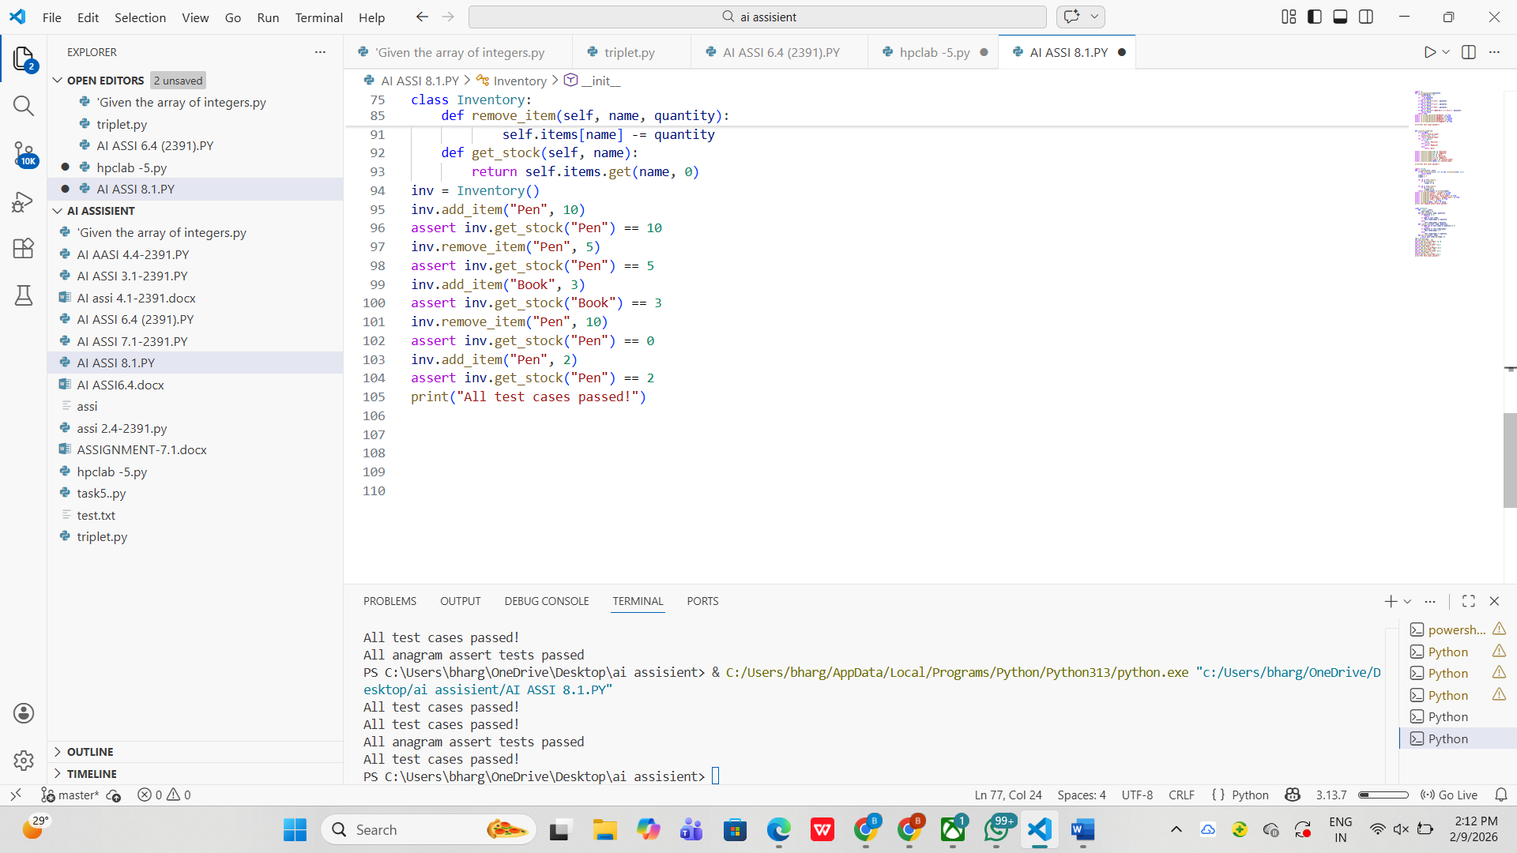
Task Description #5 (Date Validation & Formatting – Apply AI forData Validation)

